**Avalon – Group Board Game Analysis**

# **Overview**

# 

# Avalon is a game of good versus evil, a fantasy turn-based game of 5 - 10 players. It is a game in which players have hidden loyalties and must use their deduction skill to find the true identity of players. Players may make claims at any point in time during the game. Discussion, accusation, and logical deduction are all equally important in order for good to prevail, where as manipulation and deception are key elements to playing the game as evil characters

# **Game Objectives**

* Good’s aim is to have 3 success quests
  + Merlin is to encourage by discretion who the evil character are and to manipulate for good to win
* Evil’s aim is to sabotage by votes, the good characters and find and kill Merlin by the end of the game

# **Core Experiences**

* Discussion - Determining people's opinions, and discussing them
* Deception - The evil team making the good players appear as evil. Merlin trying to hide his identity
* Deduction - Evil deducing who merlin is and the good team discovering the evil characters

# 

# **Key Mechanics**

* Voting Mechanics
  + Voting on quest team creation, and on and voting on quest failure and success
  + Creating trust and mistrust
  + By tokens and/or cards
* Shuffling of cards, creating randomization
  + Element of mystery
* Discovery phase
  + Establishing player identity
  + I.E. Merlin knowing the evil characters, the evil characters knowing each other
* Special player abilities
  + Merlin can see who everyone is
  + The Assassin can kill Merlin if they discover who they are

**Critical analysis**

* Trust and mistrust is created by observing how other players act, vote, and discuss on quests and other players
* The game is successful in engaging the players to discuss and deduce by using the voting mechanics and the anonymity of results.
* Rules could be improved by being clearer in the explanation of the rules.

# 

# **How feedback is delivered**

* Cards/tokens can determine how the game progresses
  + Helps to deduce the loyalty of the players
* By the assassination phase, seeing the result of the assassin accusing a possible player playing merlin, by success or failure
* Merlin knowing who is evil through putting their thumbs up, and implication to other players

# **A distinct summary for each of the cognitive, social and emotional:**

Cognitive

* Causes players to judge other players based on their actions, and results
* Causes players to think strategically in order to figure out who is who

Social

* Causes players to discuss their thoughts and rationale on who is who and why
* Causes players to discuss questing teams that may be advantageous to them

Emotional

* Sensing a build up of tension as the game nears an end
* It can create a sense of joy if by successfully guessing, killing the merlin character

# **Game Loop**

# 

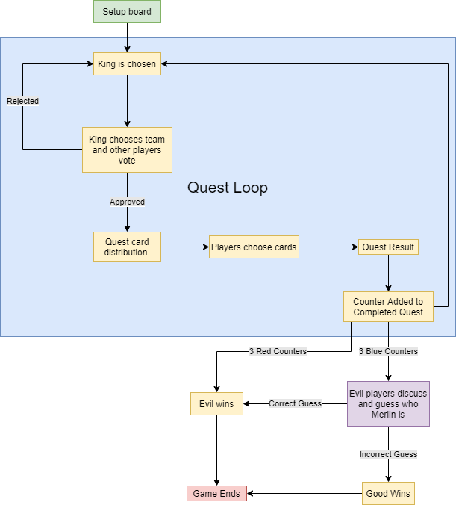

# 

# Tsuro Analysis

## Overview

Tsuro is a two to eight player game all about people taking paths. The game consists of cards with multiple routes that all intertwine in one way or another, making large paths that can span the board. Players place these cards in hopes of making a path that does not lead to the edge of the board for themselves, however the cards can also interfere with other players to put them at a disadvantage.

**Objective/Goal**

* To be the last player on the board whilst leading other players off it

**Core Experiences**

* Strategising on the best route to go down
* Hindering others’ progression

**Key Mechanics**

* Cards – must connect, and be placed in any orientation
* Hand – having 3 cards at all times
* Card Pile – player draws back to 3 from the limited card pile
* Dragon Card – signifies the first player to draw should the deck deplete & replete
* Game Piece – player can only move along one continuous line

**Gameplay Loops**

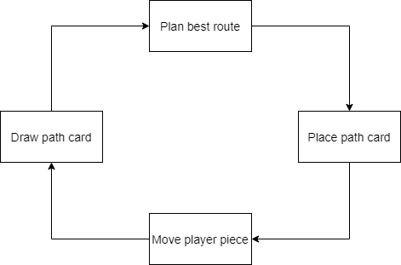

**Critical Analysis**

Tsuro allows a broad audience to play, as it is such a simple game with minimal rules. Players can only put a card in front of their piece, so the challenge comes from the many different directions the cards can go. This makes calculating another player’s move a rewarding challenge. The game is also good for people who don’t have much time as due to its simplicity, it makes for a quick experience.

**Feedback**

The player gets feedback when:

* Moving their piece along the created path
* Drawing cards
* Another player moves on the board

**Summary**

* Cognitive (makes the player think)
  + Planning a route through the many paths – the player has to think ahead a few moves
  + The board combinations with the 3 cards in your hand – the game rewards utilising most relevant card rather than playing randomly
  + Other people plotting routes near you – player must predict their path and figure out how to avoid/redirect them
* Social (makes the players interact)
  + The game does not force players to interact in any way
* Emotional (makes the player feel)
  + Frustration – When all the cards in your hand lead yourpiece off the board
  + Annoyance – When somebody eliminates you by placing a card that leads off the board
  + Satisfaction – Winning the game

# One Night Ultimate Werewolf Analysis

## Overview

One night ultimate werewolf is a five to ten player game about a village of town people, and a werewolf hiding amongst them. The townsfolk must work together to find the werewolves, and the werewolves must trick the town into thinking someone else is the werewolf.

The players are assigned role cards which decide allegiance, and the three leftover cards are put in the middle. The night phase begins, and players listen to the narrator to fulfil their role abilities. The day phase begins, and players spend their time discussing different possibilities before having to vote on who the werewolf is. If one werewolf is voted on the town wins, but if none are voted out the werewolves win.

**Objective/Goal**

* Correctly pick the werewolf if town member
* Deceive the town people if werewolf

**Core Experiences**

* Team work – working with who you think your team is
* Deducting narrative – figuring out the roles in your head

**Key Mechanics**

* Roles & Abilities – are randomly given to players and can affect the game in different ways e.g.
  + Seer (can view another players card, or two from the centre)
  + Robber (can swap and view someone’s card with them self)
  + Troublemaker (can swap two other players’ cards)
* Card Pile – there are 3 excess cards face down in the centre
* Tokens – can be placed on players card showing the general opinion of their identity
* Day phase – players trick each other to slip up or reveal a lie/discover everyone’s true identity
* Night Phase – when the roles use their abilities and some players become aware of each other’s role

**Gameplay Loops**

The game doesn’t have a loop as each round is self-contained.

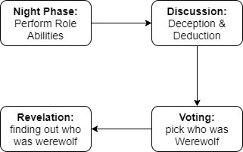

**Critical Analysis**

One night ultimate werewolf is complicated in terms of how many roles with different and complicated abilities there are. However, the instructions are generally straight forward with everyone in the group grasping the rules quickly. The difficulty of the game is not steep as it can be set by the player through gradually adding the more complicated cards or starting off with the crazy roles.

**Feedback**

The player gets feedback when:

* Swapping players’ cards – you know information that others don’t
* Everyone flips their card at the end – everyone knows each other’s roles and why they acted certain ways
* A token is placed on a player – as everyone understands the general opinion of that player’s role

**Summary**

* Cognitive (makes the player think)
  + The different roles in the game makes players think about the different possibilities
  + Having to construct plausible lies to win
  + Using the different role abilities in the night phase to put the player at an advantage
* Social (makes the players interact)
  + Roles – with each role having different knowledge the players must strategically share the truth of their insight or lie
  + Teams – forces cooperation and sharing information between players for the team to win
  + Werewolf – the role makes the player lie to the other players and work with their team mates
* Emotional (makes the player feel)
  + Confusion – game creates scenarios where some players need to contradict each other
  + Joy – the night phase makes a complicated series of events, therefore giving the player satisfaction when deducting what happened
  + Frustration – because the game promotes distrust, the player feels bad when they are not trusted